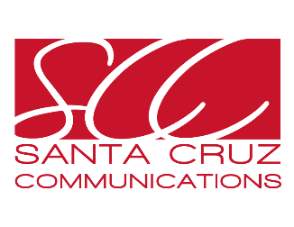

Santa Cruz Communications: Spring Internship
10-15hr/week – Academic credit only.
Santa Cruz Communications, a leading independent communications firm, is looking for a Public Relations Intern to provide support to our group of professionals based in Miami and Los Angeles. This is an opportunity to work remotely and learn first-hand from PR professionals with over 25 years of experience.

Responsibilities:
- Draft PR materials such as press releases, bios and pitch letters.
- Conduct media pitching via phone and email.
- Conduct follow-up via phone and email with clients and other stakeholders, as needed.
- Create engaging social media content across various channels, including monthly calendars and graphics. Manage posting on social media management platforms.
- Conduct media research. Create editorial calendars and target media lists.
- Conduct media monitoring. Develop clip reports.
- Attend weekly staff meetings.
- Provide general support to team including, proofreading documents, assisting with client monthly reports, researching industry trends, and others.

Qualifications:
- Junior, senior or graduate-level students in the Communications, Public Relations or Journalism fields.
- Excellent writing skills.
- Bilingual a plus, but not required.
- Fast learner, team player and self-efficient.
- Knowledge of Microsoft Office. Basics skills on Canva and Hootsuite, desirable.

About Santa Cruz Communications
With 19 years in the market, SCC is a leading independent communications firm driven to deliver solutions for companies seeking to engage with their target audiences, be it in the General Market or U.S. Hispanic, in English and/or Spanish. Our passionate team of highly experienced and creative bilingual and bicultural professionals is based in Miami and L.A., spanning across time zones to cover all major U.S. markets. Strategy and creativity are our strength. We develop and implement compelling campaigns that impact clients’ business goals, with engaging content that tells your story and connects with your target audience across various channels. We boast a proven track record for developing PR campaigns for clients in a variety of industries including entertainment, education, lifestyle, environment, and more. For more information, visit: www.santacruzpr.com
Please send resume and cover letter to: Danixa Lopez, Senior Director at danixa (at) santacruzpr.com

