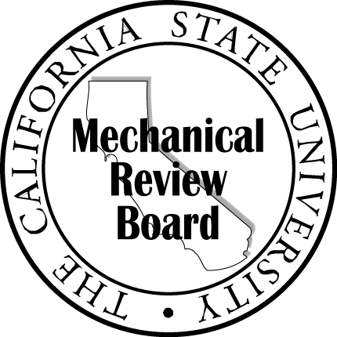

The California State University Mechanical Review Board

[Date]

[Name]
[Title]
[Department]
[Campus]
[Address Line 1]
[Address Line 2]

Subject: [Project] 75% Schematic Design Mechanical Systems Review Concurrence

Dear [Campus Project Manager]:

We have reviewed the 75% Schematic submittal, had several meetings with the project team and discussed the general mechanical system concepts with them. In general, the mechanical systems that are being proposed are reasonable. We will continue to work with your team to help provide a successful outcome.
We look forward to reviewing the 100% Schematic Design submittal.
Please feel free to contact us if you wish to discuss the details of the design review further.

Sincerely,

[Company]

[MRB Member Name]
[Title]

cc: Rachel Patterson, Chancellor’s Office
Ebi Saberi, Chancellor’s Office

